



OPPORTUNITES WITH EXPERINCE
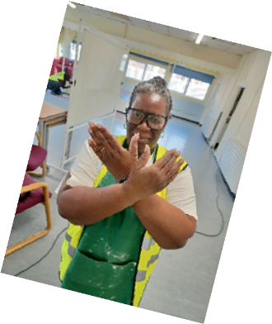
O-W-E C.I.C presents 'Walk Tall' Case Study




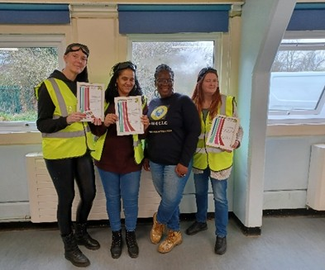

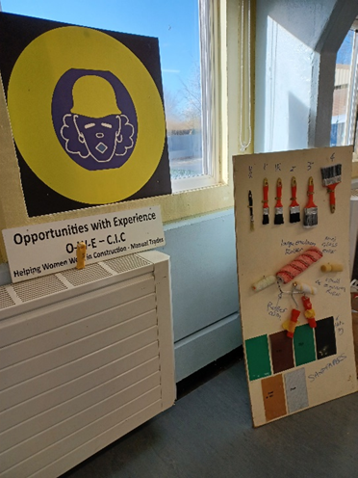
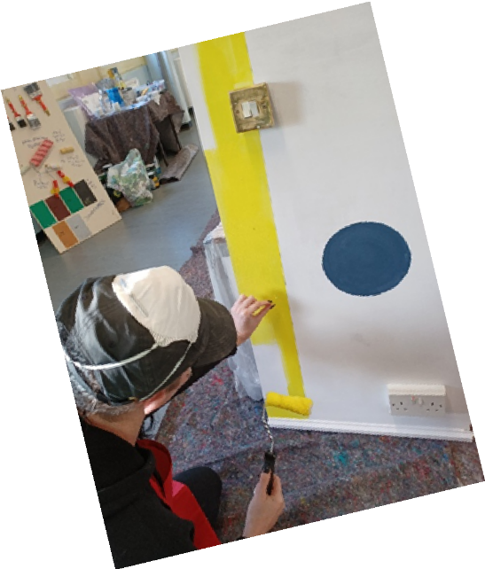
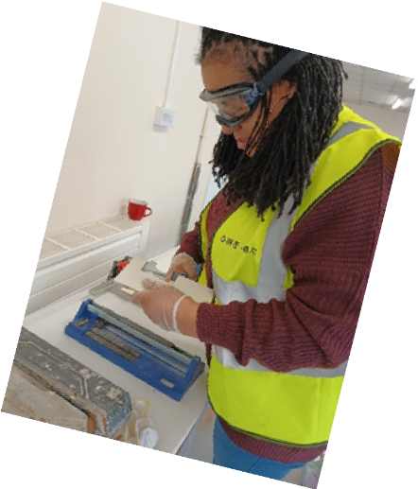

Let’s applaud our fantastic women who attended the latest '11-day programme, 'We can, She can, You can...work in practical trades' held at Walk Tall in Swanscombe Heritage Centre.
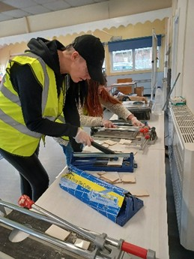
Our Programme delivered - Training in interior decorating Commercial work experience Embedded Practical skills Training for a CSCS Green card Empowerment & Confidence Building
Tradeswomen showcasing practical trades
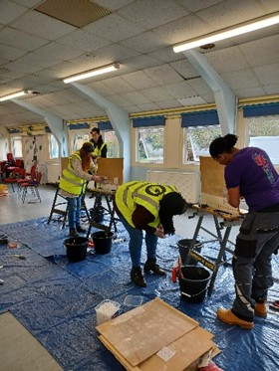

O-W-E Impact!!
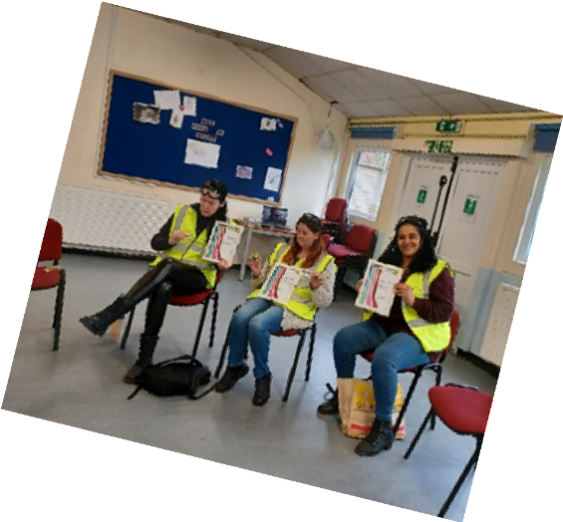
One learner stated, 'I feel like I've achieved so much, I've always suffered with anxiety, and I suppose just felt 'written off'. I've always had an interest in interior design and had a thought I’d love to have a go; however, I was always told by parents this was a man’s role and not for me. Now I've completed the course, passed, and got the card - it’s amazing.

It’s been really empowering. I've even been told by a few other women its inspirational what I've achieved, and they would like to do it. Currently am looking for work, interior design / painting and decorating apprenticeships or something like that, it’s changed me, and it feels great!
Thank

''
We Love the community project.
I think it is very useful for the ladies and much needed!
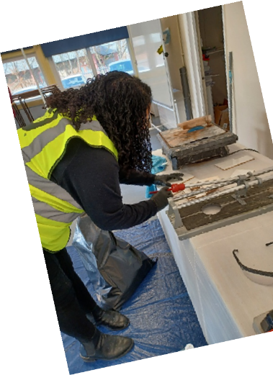
Great for the community, the sort of community project where everybody wins'' Ann Duke CEO Walk Tall

From us at O-W-E-C.I.C to Walk Tall & Kent Community Foundation'
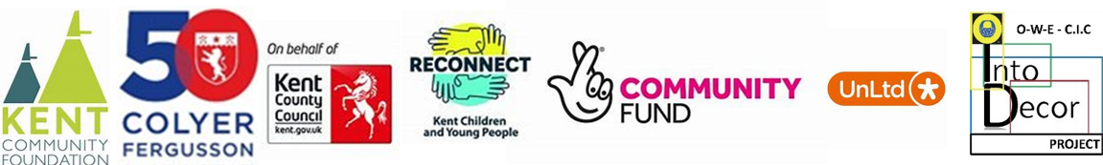
you!
Contact Us owecic@gmail.com W: o-w-e.cic.org.uk

