



12 days Interior Decorating plus CSCS Training Course

Especially for those young women/mums aged 18+ interested in painting & decorating and or gaining a CSCS card

Learn interior decorating skills and have a real opportunity for
On Site Work Experience

Women in Construction Awareness Programme (1 day)
Practice simulated trades skills in interior decorating (3 days)
Complete work experience on a local community project (3 days)
Attend the L1 Award in Health and Safety in a Construction Environment course. Includes booking CSCS test (3 days)
Presentation of Certificate of Achievement (1 day)
Starts in 9th April 2019
*We start at 09.30am and finish at 3.30pm, however we are flexible with start and finish times*

Sessions will be held at
Tree Community Centre
Address: Cedar Rd, Dartford DA1 2RS
Phone: 074 9654 7214
We have limited places so booking your space is required!
For more information contact:
angela.steele1@o-w-e.org.uk or owecic.office@o-w-e.org.uk

Text: 074 9654 7214

Please book by Wednesday 3rd April 2019 to guarantee your space

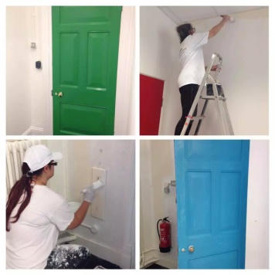
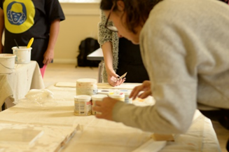

Light refreshments provided
We’ve done preparing the surfaces, sanding and filling, the use of different kinds of paints. I’m looking to be a painter and decorator and I’ve already had a few days of paid work. Before, I didn’t have too much hope, but now I have the skills to focus on a new career.” Winsome
“The sessions were engaging, appropriately paced and informative instruction. Angela is knowledgeable, interesting and experienced.
An inspiration”!
Abi White

